**Synergetica Informal Counselling Programme**

*Become a Supportive Counsellor, this recognized occupation in SA provides job opportunities. You will learn how to apply counselling and interpersonal skills to start up and manage a wellness counselling centre and facilitate for your clients things such as problem solving, stress management, personal development and growth, lifestyle management, trauma reduction and relationship improvement.*

**Counselling** is a fulfilling service to people inspired by the virtues of empathy,

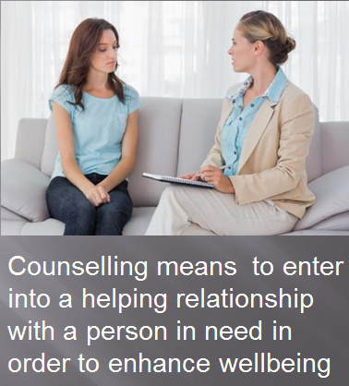care and love. Counsellors are sociable individuals with who have a keen interest in people and who can communicate well. Wellness Counselling is a comprehensive approach to counselling in rendering support and help to the total person - body, mind and spirit.

**Counselling** means “the entering into a helping relationship with the client with the aim of rendering support, encouragement and guidance in order to solve problems, improve relationships and learn life skills to improve coping skills”.

**T**here is a vast need in SA for counselling professionals on primary health care level that can provide effective counselling services over a wide spectrum of support and care. Hence, you will be trained in the use of a variety of counselling techniques and supportive tools.

**How do I do the course?**

This informal course programme is comprised of 6 topics and is ideal for:

* People without any previous qualifications interested to become counsellors
* Candidates who have other relevant qualifications, but lack training in the context of wellness.

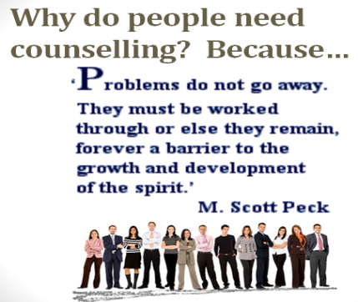The course follows a distance training programme and can be completed over 10 months by completing the prescribed assignment for each short topics and gaining practical experience in counselling.

You can also build up and compile a Portfolio of Evidence (POE*). The POE is a record of all your work such as assignments and tests as well as a record of your practical work. It must also indicate the hours and the nature of the work. Upon completion of the short courses you will be able…

* To apply counselling skills and techniques related to wellness and counselling.
* To apply interpersonal and communication skills with clients.
* To practice lifestyle management and wellness improvement in a counselling context.
* To earn an income by being able to administrate, manage and market a counselling centre/consultation practice
* To follow an ethical code and express professionalism within scope of practice.

*This POE can, upon completion, serve to possibly provide credits to you towards further accredited studies in counselling through one of our training partners. This way a lifelong learning pathway is created for our students.

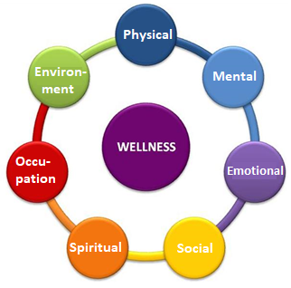**The wellness context**

Counsellor work in the wellness domain which is a comprehensive health care concept that is promoted by the World Health Organization (WHO). Wellness describes the health status of people on physical, psychological, and social levels (see diagramme) which means that it covers a wide spectrum. Some counsellors who work on more advanced levels of counselling also make use of complementary modalities such as herbal support, life style coaching, nutritional support, movement and body therapies and energy screening techniques as part of the broad approach to counselling. The World Health Organization defines health as a positive state of mental, emotional, physical and social wellbeing (WHO policies).

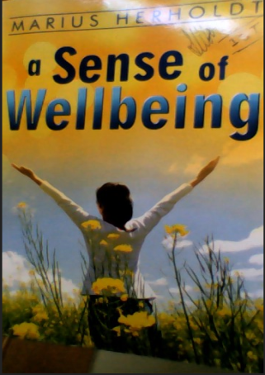**Synergetica** is a student support centre that will support you in completing the short courses. The 21 hectare Synergetica Campus is situated since 2002, just outside of Pretoria.

****The short course programme is not academically accredited, but it is endorsed by the Counselling association and provides credits towards further accredited training through our training partners. Qualified facilitators are available to assist you and you may e-mail them at any time when you need help. Optional classes in wellness are also offered at the campus nearby Pretoria from time to time. If you cannot attend the classes, a copy of the class presentation can be made available to you so that you do not miss out on the training. The Synergetica office can also make names of counsellors in your area available to you as possible option for practical experience.

The training material of Synergetica is approved by the Council for Counsellors in SA (CCSA) and the ASCHP and you will also enjoy registration at the association on student level in order to commence with practical work. Once you have completed the training programme, you may apply to upgrade to institutional counsellor level or migrate via RPL to supportive counsellor level (NQF registered designation) at the professional body: Association for Supportive Counsellors and Holistic Practitioners (The ASCHP).

**Registration**

The tuition fees pay for the package will include your

* **Training material** – a learner guide is provided for each topic
* **PowerPoint visual guides** that you can run on your laptop
* **Tutoring support** from facilitators that will mark your assignments
* **Text book**, *A Sense of Wellbeing* that provides and overview of wellness counselling

**Short course programme**

The text book, A Sense of Wellbeing is the only prescribed book and is also included as reference guide for your training. The content of the short courses are set out below:

1. **Individual Counselling: tools, techniques and theory**

* Explain the functions and scope of practice of a counsellor.
* Set up an enabling counselling environment.
* Explain the principles and processes of counselling.
* Explain the role of values and attitudes in behaviour and counselling.
* Apply a counselling process in a specific context.
* Reflect on the counselling process.

1. **Practice Management and Client Rights**

* Explaining clients’ rights.
* Discussing international codes, charters and conventions relating to clients’ rights.
* Applying knowledge of relevant legislation and policy to clients’ rights.
* Explaining the rights and responsibilities of counsellors and other care service providers.

1. **Professional Ethics**

* Explain professional ethics in a counselling context
* Analyse and apply ethical principles and legal aspects relating to counselling practice

1. **Group Counselling**

* Describe the elements of successful group counselling
* Explain a group counselling process
* Apply a group counselling process to a counselling interaction in a selected context
* Reflect on the group counselling interactions

1. **Promotion of Health and Wellness**

* Wellness theory and practice
* Identify environments for the promotion of health and wellness.
* Investigate personal factors that impact on or influence health and wellness.
* Analyse information relating to health and wellness.
* Inform clients about applications of wellness lifestyle.

1. **Screening and Health Profiling**

* Explain human development
* Differentiate between functional and dysfunctional behaviour
* Describe the impact of lifestyle orientation on behaviour and adaptation
* Identify causes and signs of health and wellness dysfunction
* Conduct screening and compile a health profile

For more information and registration please contact the office